ESM410 Assignment 1:
Problem Pictures Task - Creating open-ended questions

Student Name: Kara Elizabeth Large

Student Number: 210598248

Campus: Burwood

PLAGIARISM AND COLLUSION Plagiarism occurs when a student passes off as the student’s own work, or copies without acknowledgement as to its authorship, the work of any other person. Collusion occurs when a student obtains the agreement of another person for a fraudulent purpose with the intent of obtaining an advantage in submitting an assignment or other work. Work submitted may be reproduced and/or communicated for the purpose of detecting plagiarism and collusion.

DECLARATION I certify that the attached work is entirely my own (or where submitted to meet the requirements of an approved group assignment is the work of the group), except where material quoted or paraphrased is acknowledged in the text. I also certify that it has not been submitted for assessment in any other unit or course.

SIGNED: KARA LARGE | DATE: 19/08/2013

An assignment will not be accepted for assessment if the declaration appearing above has not been signed by the author.

YOU ARE ADVISED TO RETAIN A COPY OF YOUR WORK UNTIL THE ORIGINAL HAS BEEN ASSESSED AND RETURNED TO YOU.

Assessor’s Comments: Your comments and grade will be recorded on the essay itself. Please ensure your name appears at the top right hand side of each page of your essay.

Checklist
All points must be ticked that they are completed before submission.
Requirements checklist: | Tick completed
The rationale addressed the rationale prompt in the assignment description. | ♥
The rationale included relevant citations/references – which are stated on the final page. | ♥
Created 3 quality problem picture photos. | ♥
The photos MUST be original photos taken by yourself. | ♥
Location of photos are stated, e.g. Taken at Deakin foreshore. | ♥
Developed an educationally sound set of 3 mathematical questions for each photo. | ♥
If your photo has numbers that you are referring to in the problem, the numbers MUST be clearly visible. e.g. a shop opening times must be able to be read in the photo. | ♥
Open-ended questions are creative and strongly relate to mathematical aspects that children would be familiar. | ♥
Matched each problem with the appropriate mathematical content, year, definition and code from the Australian Curriculum: Mathematics | ♥
Each photo has an accompanying question for lower, middle and upper primary levels. | ♥
Questions showed a development in complexity from lower to upper primary. | ♥
Grade level stated next to each question. | ♥
Each question is accompanied by three possible correct responses. | ♥
Reporting of the trialling of 3 questions from 3 different photos with an appropriately aged child or children. | ♥
There is evidence of reference to problem-picture web site / Peter Sullivan’s eLecture i.e. problems were open-ended. | ♥
Problem pictures were collated into a word document using the assignment template. | ♥
File size of the word document is under 4mb. | ♥
Assignment is uploaded to the Cloud Deakin dropbox on time. | ♥

In order to pass this assignment you must have fulfilled all aspects of the checklist and submitted your work by the due date.

Rationale for the use of problem pictures in the classroom

It is well known that teaching and learning should be flexible and centered on the student and their interests. Bess and Brandt (cited in Conklin, W 2010, p.190) state that this is because,“...when students are engaged in something of interest or by choice they are essentially more engaged in the learning process”, thus the use of open ended problem pictures engage students as they allow students, “...opportunity to make choices” (Bess and Brandt (cited in Conklin, W 2010, p.190), whilst can still relate to their interests.
Using open ended problems in the classroom not only allow for students to be exposed to providing a variety of answers rather than be restricted to one – therefore able to make a choice, but they also stimulate student thinking. They allow students to approach the task at their own level and in their own way and thus they foster creative thinking, investigation and decision making. It is through these skills that the questions are helping students to learn, as the answer to it requires more than a simple remembered fact (Sullivan, P 2005).
Incorporating problem pictures into open ended problems further enhance students learning as they enable students to begin to see and understand the connection of mathematics learnt within the classroom and how it applies to the outside world (Bragg, L. A & Nicol, C 2011).
Open ended problem pictures support my teaching in the classroom as they help to stimulate discussion amongst the class when reflecting upon each student’s various responses. Because of the nature of the question, in that a variety of responses can be made, the resulting discussion can effectively enhance other student’s perceptions of that particular topic or introduce them to a new approach to work out the answer. Similarly, due to the variety of responses that can be achieved, the questions are easy to differentiate to a range of student abilities as they allow students to creatively respond to answers and express their ideas. Wendy Conklin emphasises the importance of differentiation within the classroom by stating that,
“This is important because some students who might otherwise go unnoticed because they normally underperform, can rise to the occasion and take ownership of their work” (2012, p.190).
This supports my teaching in the classroom as it ensures that all students are being catered for as they are able to respond to the question whilst following their own understanding of it. Consequently this also benefits me as I am able to see each student’s preferred method and approach to answering specific questions on different topics and thus am able to observe the areas that students need to develop.

References:

Bragg, L. A & Nicol, C 2011, Seeing mathematics through a new lens : using photos in the mathematics classroom, Australian mathematics teacher, vol. 67, no. 3, Fall, pp.3-9, Deakin Research Online database.
Conklin, W 2010, Differentiation strategies for mathematics, Shell Education, Huntington Beach, California, Ebook Library database.
Sullivan, P. (2005). Teaching mathematics to classes of diverse interests and backgrounds. [online electure], Deakin University.

Problem Picture 1

Location: Picture taken at my home.
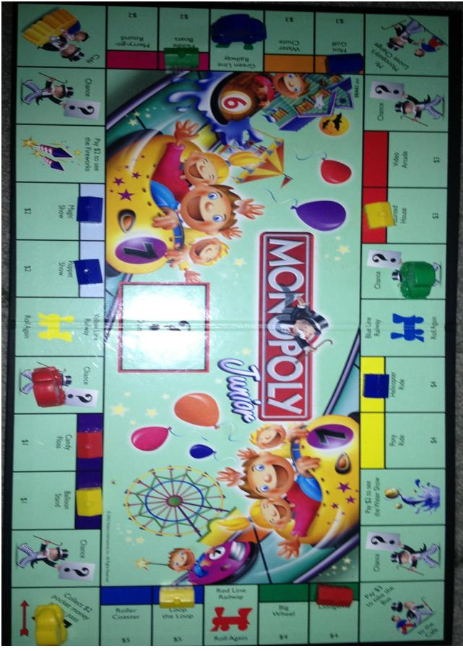

Problem Picture 1 - Questions

Question 1: Grade Two Lower Primary
How many houses does each car/player have? If your friend can’t see the game how would you show them how many houses each player/car had? Write a sentence about what player you think will win and will lose.

Answers to Question 1

5
4
3
2
1
 | Red Car | Blue Car | Yellow Car | Green Car
Red Car | 2
Blue Car | 4
Yellow Car | 3
Green Car | 1
- 2) 3)

The blue car/player will win because they have the most houses.
The green car/player will lose because they have the least houses.

Mathematical intent:

Content strand/s, year, definition and code
Statistics and Probability – Data representation and interpretation
Year 2 – Create displays of data using lists, table and picture graphs and interpret them (ACMSP050)

Proficiency strand/s
Level 2 - Reasoning includes using known facts to derive strategies for unfamiliar calculations, comparing and contrasting related models of operations, and creating and interpreting simple representations of data

Question 2: Grade Four Middle Primary
Identify symmetrical objects in the picture and draw a line through the point of symmetry. Place some of these shapes into a symmetrical pattern.

Answers to Question 2
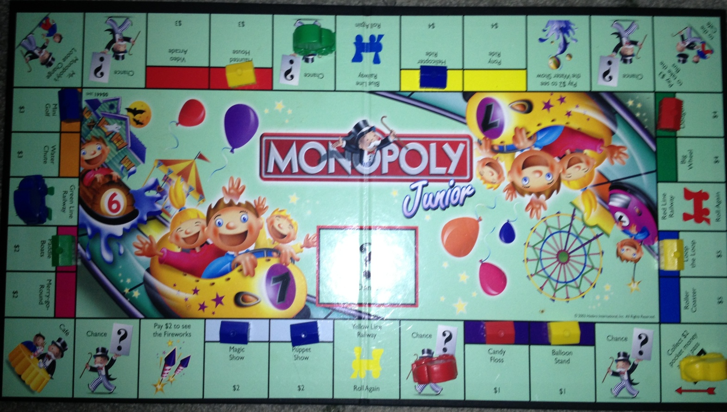
Stars, houses, letters, Ferris wheel, top of tent, bat, balloon, arrow, rectangle,

Any pattern that is symmetrical on each side.

Mathematical intent:

Content strand/s, year, definition and code
Measurement and Geometry – Location and transformation
Year 4 – Create symmetrical patterns, pictures and shapes with and without digital technologies (ACMMG091)

Proficiency strand/s
Level 4 - Fluency includes recalling multiplication tables, communicating sequences of simple fractions, using instruments to measure accurately, creating patterns with shapes and their transformations, and collecting and recording data
Level 4 - Understanding includes making connections between representations of numbers, partitioning and combining numbers flexibly, extending place value to decimals, using appropriate language to communicate times, and describing properties of symmetrical shapes

Question 3: Grade Six Upper Primary

The monopoly bank has just announced a sale on the prices of the carnival stands. Choose two different dollar amounts on the board and calculate the prices of them after a discount of 10%, 25% and 50% have been applied to each. Show your workings. You are allowed to buy one carnival stand that has been discounted, which one would you choose and what discount would it have?

Answers to Question 3

- $1 10% =10 divided by 100 = $0.10 = 10% off $1.00 is $0.10 = $1.00 - $0.10 = $0.90
25% =25 divided by 100 = $0.25 = 25% off $1.00 is $0.25 = $1.00 - $0.25 = $0.75
50% =50 divided by 100 = $0.50 = 50% off $1.00 is $0.50 = $1.00 - $0.50 = $0.50

- $2 10% =10 divided by 100 x 2 = $0.20 = 10% off $2.00 is $0.20 = $2.00 - $0.20 = $1.80
25% =25 divided by 100 x 2 = $0.50 = 25% off $2.00 is $0.50 = $2.00 - $0.50 = $1.50
50% =50 divided by 100 x 2 = $1.00 =50% off $2.00 is $1.00 = $2.00 - $1.00 = $1.00

- $3 10% =10 divided by 100 x 3 = $0.30 =10% off $3.00 is $0.30 = $3.00 - $0.30 = $2.70
25% =25 divided by 100 x 3 = $0.75 = 25% off $3.00 is $0.75 = $3.00 - $0.75 = $2.25
50% =50 divided by 100 x 3 = $1.50 = 50% off $3.00 is $1.50 = $3.00 - $1.50 = $1.50

- $4 10% =10 divided by 100 x 4 = $0.40 = 10% off $4.00 is $0.40 = $4.00 - $0.40 = $3.60
25% =25 divided by 100 x 4 = $1.00 = 25% off $4.00 is $1.00 = $4.00 - $1.00 = $3.00
50% =50 divided by 100 x 4 = $2.00 = 50% off $4.00 is $2.00 = $4.00 - $2.00 = $2.00

- $5 10% =10 divided by 100 x 5 = $0.50 = 10% off $5.00 is $0.50 = $5.00 - $0.50 = $4.50
25% = 25 divided by 100 x 5 = $1.25 = 25% off $5.00 is $1.25 = $5.00 - $1.25 = $3.75
50% = 50 divided by 100 x 5 = $2.50 = 50% off $2.50 is $2.50 = $5.00 - $2.50 = $2.50
I would choose: The $1 carnival stand with the 50% discount because it will be the cheapest stand – $0.50
The $5 carnival stand with the 50% discount because it will be the cheapest but give me the most money when other cars/players land on it.
The $5 carnival stand with the 50% discount because it is the biggest discount.
Numerous other variations using mathematical reasoning.

Mathematical intent:

Content strand/s, year, definition and code
Number and Algebra – Money and financial mathematics
Year 6 - Investigate and calculate percentage discounts of 10%, 25% and 50% on sale items, with and without digital technologies (ACMNA132)

Proficiency strand/s
Level 6 - Fluency includes representing integers on a number line, calculating simple percentages, using brackets appropriately, converting between fractions and decimals, using operations with fractions, decimals and percentages, measuring using metric units, and interpreting timetables
Level 6 - Problem Solving includes formulating and solving authentic problems using fractions, decimals, percentages and measurements, interpreting secondary data displays, and finding the size of unknown angles

Report of Trialling Problem Picture 1 Question Two

Child’s pseudonym, age and grade level:
Holly 8 years old Grade Three

Original Question:
Identify symmetrical objects in the picture and draw a line through the point of symmetry. Place some of these shapes into a symmetrical pattern.

Child’s response to the question:
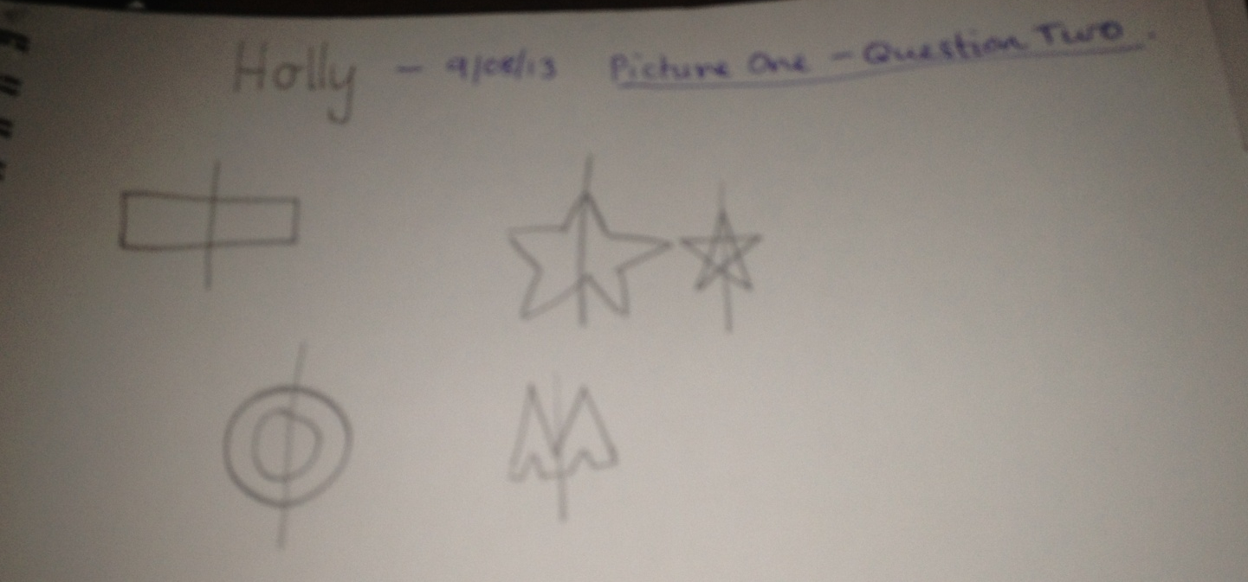

Reflection on child’s response:
Holly answered my question as expected after I rephrased both ‘identify’ and ‘place’ with ‘draw’. I had to rephrase these words as she showed a slight sign of confusion that looked as if she thought she had to draw the line of symmetry on the photo itself. This identified to me that the language I had chosen to use in the phrasing of my question was slightly inappropriate for her age.
Holly’s responses to the question identified that although she had a good understanding of symmetry, she did not have a complete grasp on it. This was shown through her identification of the line of symmetry in all shapes being a vertical line down the middle when in fact two shapes (rectangle and letter O) could have had their line of symmetry drawn either vertically or horizontally. It was also shown in her inability to draw a symmetrical pattern, although this could be due to the topic not being taught yet as it is a grade four standard. In saying that, when asking this question I was expecting her to be unable to complete this aspect of the task due to that reason anyway.
I believe the question addressed the mathematical intent relating to Holly as a grade three student as it states in a level four proficiency strand (Australian Curriculum Assessment and Reporting Authority [ACARA], 2012) that students are, ‘describing properties of symmetrical shapes’. Thus she did identify symmetrical shapes and was able to identify that they were the same on both sides of the line of symmetry.

Rephrased Question:
Identify and draw symmetrical objects in this picture and draw a line through any points of symmetry. Draw some of these shapes to make a symmetrical pattern.

References:
Australian Curriculum Assessment and Reporting Authority, (2012), The Australian Curriculum, Retrieved August 2, 2013, from http://australiancurriculum.edu.au

Problem Picture 2

Location: Photo taken in my kitchen at my home.

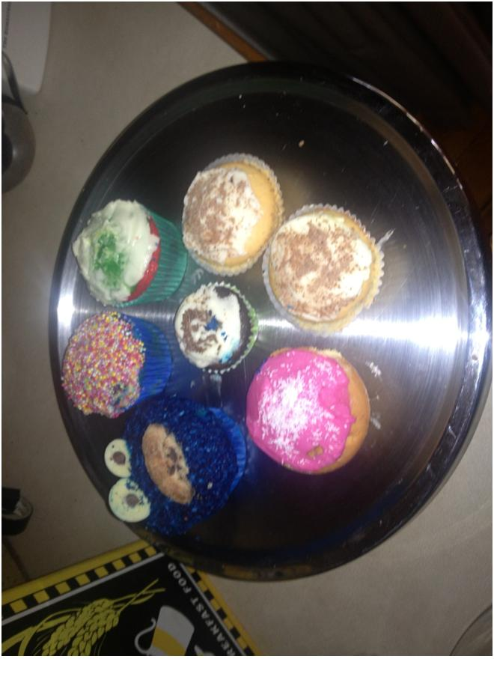

Problem Picture 2 - Questions

Question 1: Prep Lower Primary
Charlie ate one cupcake every day for a week. List the days of the week that Charlie ate a cupcake. What do you do on each day of the week? You can write or draw your answers.

Answers to Question 1

Sunday – Football – Go to the park – Go for a bike ride – Go to church
Monday – School – Dancing - Basketball
Tuesday – School – Piano - Soccer
Wednesday – School – Art - PE
Thursday – School – Netball – Nan’s House
Friday – School – Fish and Chips - Basketball
Saturday – Football – Dancing – Netball

Various drawings as to what each student does on each day of the week.

Mathematical intent:

Content strand/s, year, definition and code
Measurement and Geometry – Using units of measurement
Prep - Connect days of the week to familiar events and actions (ACMMG008)

Proficiency strand/s
Level One - Fluency includes counting number in sequences readily forward and backwards, locating numbers on a line, and naming the days of the week

Question 2: Grade Three Middle Primary
James ate one third (1/3) of his cupcake. Billy ate one fifth (1/5) of his cupcake. Nicole ate half (1/2) of her cupcake. Draw circles to represent each cupcake and shade the amount each person ate. If you could eat one of the cupcakes after each person had eaten a part of it, which one would you eat and why? How much of the cupcake are you eating?

Answers to Question 2
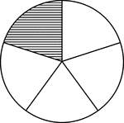
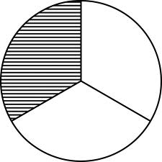

James Billy Nicole

- James Cupcake – 2/3, two thirds of James cupcake – I would eat James’ cupcake because there isn’t too much to eat nor is there not enough to eat, it is in the middle ect.
- Billy’s Cupcake – 4/5, four fifths of Billy’s cupcake – I would eat Billy’s cupcake because there is more leftover to eat or more cake left on this cupcake than the others ect.
- Nicole’s Cupcake – 1/2, one half of Nicole’s cupcake – I would eat Nicole’s cupcake because I don’t like cupcakes and would want to eat the least amount of cupcake, don’t want to eat much cupcake, least amount of cake on each of the cupcakes ect.

Mathematical intent:

Content strand/s, year, definition and code
Number and Algebra – Fractions and decimals
Year Three - Model and represent unit fractions including 1/2, 1/4, 1/3, 1/5 and their multiples to a complete whole (ACMNA058)

Proficiency strand/s
Level Three - Understanding includes connecting number representations with number sequences, partitioning and combining numbers flexibly, representing unit fractions, using appropriate language to communicate times, and identifying environmental symmetry

Question 3: Grade Five Upper Primary
The cupcakes were made with flour ($1.00), eggs ($3.50), milk ($1.90) and sugar ($2.00). Estimate how much a big cupcake would of cost to make and how much the little cupcake would have cost to make.

Answers to Question 3

Rounding all amounts to nearest dollar to estimate.

1.00+4.00+2.00+2.00 = $9.00
$9 divided by 7 cupcakes = $1.30 Aprox
A big cupcake would cost more than a little cupcake because it uses more ingredients – Add on 0.10 to each big cupcake cost
$1.40 x 6 (6 big cupcakes) = $8.40. Overall total of ingredients = $9.00. $9.00 - $8.40 = $0.60
A big cupcake could cost approximately $1.40 to make. The little cupcake could cost approximately $0.60 to make.
- Rounding all amounts to estimate
1.00+3.00+2.00+2.00 = $8.00
$8 divided by 7 cupcakes = $1.10 Aprox

A big cupcake would cost more than a little cupcake to because it uses more ingredients – Add on 0.10 to each big cupcake cost

$1.20 x 6 (6 big cupcakes) = $7.20. Overall total of ingredients = $8.00. $8.00 - $7.20 = $0.80

A big cupcake could cost approximately $1.20 to make. The little cupcake could cost approximately $0.80 to make.

- Rounding one value to estimate
1.00+3.50+2.00+2.00 = $8.50
$8.50 divided by 7 cupcakes = $1.20 Aprox

A big cupcake would cost more than a little cupcake to because it uses more ingredients – Add on 0.10 to each big cupcake cost

$1.30 x 6 (6 big cupcakes) = $7.80. Overall total ingredients = $8.50. $8.50 - $7.80 = $0.70

A big cupcake could cost approximately $1.30 to make. The little cupcake could cost approximately $0.70 to make.

Mathematical intent:

Content strand/s, year, definition and code
Number and algebra – Number and place value
Year Five - Use estimation and rounding to check the reasonableness of answers to calculations (ACMNA099)
Year Five - Solve problems involving division by a one digit number, including those that result in a remainder (ACMNA101)

Proficiency strand/s
Level Five - Fluency includes choosing appropriate units of measurement for calculation of perimeter and area, using estimation to check the reasonableness of answers to calculations and using instruments to measure angles

Report of Trialling Problem Picture 2 Question Two

Child’s pseudonym, age and grade level:
Holly 8 years old Grade Three

Original Question:
James ate one third (1/3) of his cupcake. Billy ate one fifth (1/5) of his cupcake. Nicole ate half (1/2) of her cupcake. Draw circles to represent each cupcake and shade the amount each person ate. If you could eat one of the cupcakes after each person had eaten a part of it, which one would you eat and why? How much of the cupcake are you eating?

Child’s response to the question:
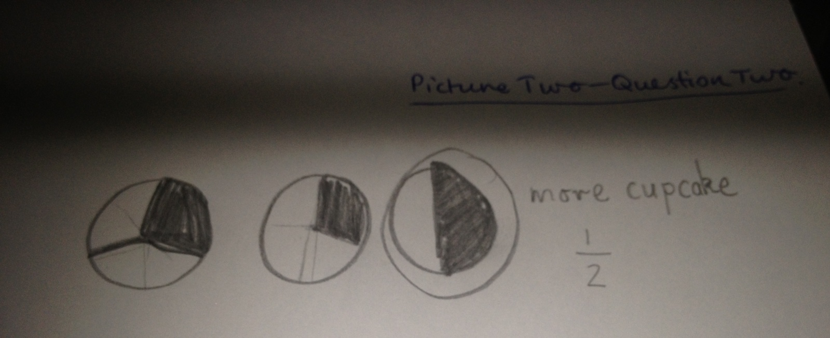

Reflection on child’s response:
I asked Holly the original question and I didn’t have to make any adjustments to it as she seemed to understand what was required of her and seemed fairly confident with answering it. In saying that, she unfortunately didn’t answer the question as I had expected her to. This is because she chose to eat Nicole’s remaining ½ of a cupcake because there was ‘more cupcake’ when infact that was the least amount of cupcake remaining on each of them. I believe Holly could have had a slight confusion with the way I had worded my question, as it can be seen in her division of the cupcakes that she understands the portions of these fractions. Thus she should have been able to identify that there was more cupcake left on the one in fifths. Yet although from this result it could also potentially be argued that Holly doesn’t have a complete understanding of fractions because of her incorrect answer.
I believe this question identified the mathematical intent of it as Holly could represent her understanding of unit fractions in thirds, fifths and halves as stated within the year three standard and the understanding proficiency strand (Australian Curriculum Assessment and Reporting Authority [ACARA], 2012). It also sought to show her understanding of the remaining multiples of these fractions in deciding on what cupcake she would eat and thus taking into consideration the different sized portions and how many were left.
Despite Holly’s incorrect answer I wouldn’t reword this question as I feel it covers the mathematical intent in the curriculum of the appropriate year (Australian Curriculum Assessment and Reporting Authority [ACARA], 2012). Also because it is open ended thus it encourages students to think, investigate and make decisions about the fractions rather than just represent them (Sullivan, P 2005).

References:
Australian Curriculum Assessment and Reporting Authority, (2012), The Australian Curriculum, Retrieved August 2, 2013, from http://australiancurriculum.edu.au
Sullivan, P. (2005). Teaching mathematics to classes of diverse interests and backgrounds. [online electure], Deakin University.

Problem Picture 3

Location: In Coles at a local supermarket

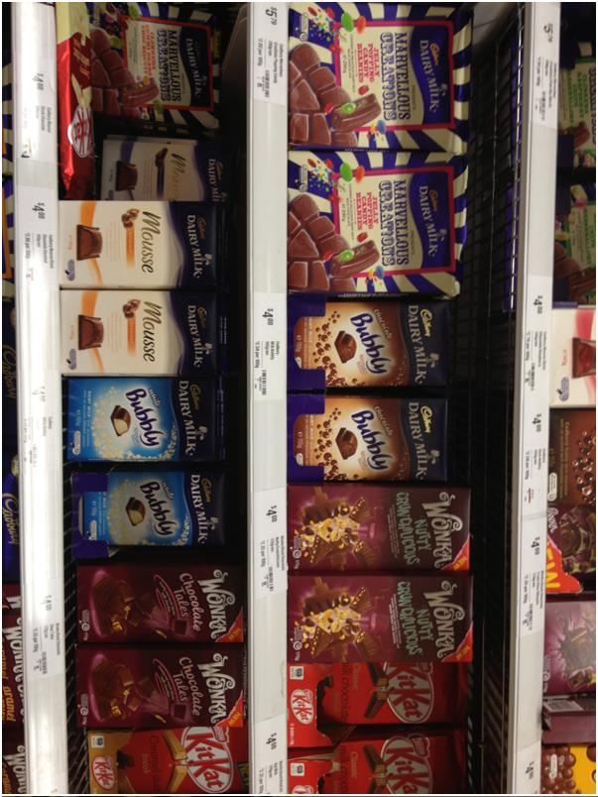

Problem Picture 3 - Questions

Question 1: Grade One Lower Primary
The top shelf of chocolate blocks is placed into a bag. You are going to pull one chocolate block out of the bag. Draw or write about something that ‘will happen’, something that ‘won’t happen’ and something that ‘might happen’.

Answers to Question 1

Various drawings along with phases that represent the following:
- WILL HAPPEN – I will pull a block of chocolate out of the bag.
WON’T HAPPEN – I won’t pull a block of mousse chocolate out of the bag.
MIGHT HAPPEN – I might pull a block of kit kat chocolate out of the bag.

- WILL HAPPEN – I will pull a block of marvellous creations, bubbly, wonka or kit kat chocolate out of the bag.
WON’T HAPPEN – I won’t pull a rabbit (any animal or object) out of the bag.
MIGHT HAPPEN – I might pull a block of wonka chocolate out of the bag.

- WILL HAPPEN – I will pull something delicious and yummy out of the bag.
WON’T HAPPEN – I won’t pull 2 chocolate blocks out of the bag.
MIGHT HAPPEN – I might pull a block of marvellous creations chocolate out of the bag.

Mathematical intent:

Content strand/s, year, definition and code
Statistics and Probability – Chance
Year One - Identify outcomes of familiar events involving chance and describe them using everyday language such as ‘will happen’, ‘won’t happen’ or ‘might happen’ (ACMSP024)

Proficiency strand/s
Level Two - Fluency includes counting numbers in sequences readily, using informal units iteratively to compare measurements, using the language of chance to describe outcomes of familiar chance events and describing and comparing time durations

Question 2: Grade Three Middle Primary
You have $10 and you buy one block of chocolate for $4. How much change will you get? Draw atleast two ways that you could have $10. Draw atleast two ways you could receive your change.

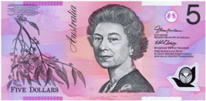
Answers to Question 2
$10 - $4 = $6.00. I will get $6.00 change.
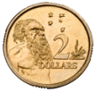
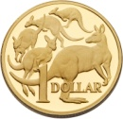
=$10.00 =$10.00
= $6.00 = $6.00
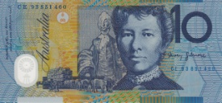
=$10.00 =$10.00
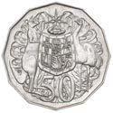
=$6.00 =$6.00

- =$10.00 =$10.00

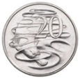
=$6.00 =$6.00

Mathematical intent:

Content strand/s, year, definition and code
Number and Algebra – Money and financial maths
Year Three - Represent money values in multiple ways and count the change required for simple transactions to the nearest five cents (ACMNA059)

Proficiency strand/s
Level Three - Problem Solving includes formulating and modelling authentic situations involving planning methods of data collection and representation, making models of three-dimensional objects and using number properties to continue number patterns

Question 3: Grade Five Upper Primary
Identify the common 2D shape in this picture. Draw and describe how you can translate, reflect and rotate this shape. Can you identify and describe the line of symmetry and rotational symmetry? What are they?

Answers to Question 3
Rectangle

Translate – move the rectangle by sliding it. Shape looks the same but just in a different place – Don’t rotate or flip it.

Rotate – move the rectangle around one point, the entire shape moves except for one point,

Reflect – flipping the rectangle, pick the shape up and turn it over to look like a mirror reflection,

Line of symmetry – Where you can fold the image and have both halves match exactly, a line down the middle of the rectangle
Rotational symmetry – Rectangle has been rotated but it still looks the same as when you first rotated it

Mathematical intent:

Content strand/s, year, definition and code
Measurement and Geometry – Location and transformation
Year Five - Describe translations, reflections and rotations of two-dimensional shapes. Identify line and rotational symmetries (ACMMG114)

Proficiency strand/s
Level Five - Understanding includes making connections between representations of numbers, using fractions to represent probabilities, comparing and ordering fractions and decimals and representing them in various ways, describing transformations and identifying line and rotational symmetry

Report of Trialling Problem Picture 3 Question Two

Child’s pseudonym, age and grade level:
Holly 8 years old Grade Three

Original Question:
You have $10 and you buy one block of chocolate for $4. How much change will you get? Draw atleast two ways that you could have $10. Draw atleast two ways you could receive your change.

Child’s response to the question:
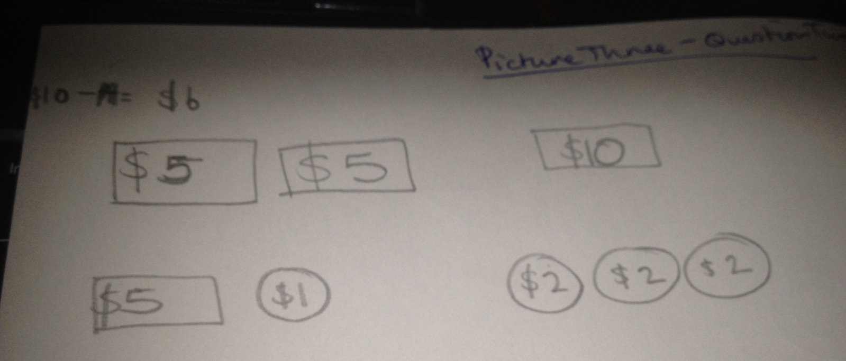

Reflection on child’s response:
Holly was very confident with this question and was eager to complete it, thus she answered the question as expected. Due to this it could be seen that Holly has a good understanding of money and money calculations due to her to speed, confidence and correct answer. Although it could also be argued the other way around as Holly answered the question using the most obvious dollar amounts. This could potentially identify a need to develop her understanding with money amounts focussing on the bigger variety of different notes and coins that can be used to create the same dollar value.
Although in saying that I do believe that the question addressed the mathematical intent of it as Holly did have to show her understanding of money values. Thus she had to represent two money values in more than one way in a scenario that she would most likely be involved with in real life which adheres to ACARA’s content strand and proficiency strand in level three (Australian Curriculum Assessment and Reporting Authority [ACARA], 2012). Either way you look at it, if Holly does or doesn’t have a good understanding of money values, the question was still effective as regardless of her level of knowledge on money and money calculations, she would still be able to answer it. This is an advantage of asking open ended questions, it appeals to a variety of ability levels (Sullivan, P 2005).
Despite the advantage of this question appealing to a variety of ability levels, if I was to reconsider rewording this question I may exclude the use of $10 being shown in the student’s money representations. This would purely be to encourage them thinking about other money combinations. In doing so the question would still be open ended yet encourage deeper thinking.

References:
Australian Curriculum Assessment and Reporting Authority, (2012), The Australian Curriculum, Retrieved August 2, 2013, from http://australiancurriculum.edu.au
Sullivan, P. (2005). Teaching mathematics to classes of diverse interests and backgrounds. [online electure], Deakin University.

References:

Australian Curriculum Assessment and Reporting Authority. (2012). The Australian Curriculum. Retrieved August 5, 2013, from http://australiancurriculum.edu.au
Bragg, L. A & Nicol, C 2011, Seeing mathematics through a new lens : using photos in the mathematics classroom, Australian mathematics teacher, vol. 67, no. 3, Fall, pp.3-9, Deakin Research Online database.
Conklin, W 2010, Differentiation strategies for mathematics, Shell Education, Huntington Beach, California, Ebook Library database.
Sullivan, P. (2005). Teaching mathematics to classes of diverse interests and backgrounds. [online electure], Deakin University.

